Network Traffic Analysis Report using Wireshark
Objective
To capture and analyze live network traffic using Wireshark on a Kali Linux virtual machine, and identify:
- Different network protocols
- Source and destination IP addresses
- One HTTP or DNS request

Tools Used
- Wireshark
- Kali Linux
- VirtualBox

Methodology
Step 1: Launch Wireshark
- Open terminal in Kali Linux
- Run command:
wireshark

Step 2: Start Packet Capture
- Select active network interface (e.g., eth0 or wlan0)
- Click Start Capture
- Let it run for 2 minutes

Step 3: Generate Traffic
During capture:
- Open a browser
- Visit any website (e.g., google.com)
- This ensures HTTP/DNS traffic is captured

Step 4: Stop Capture
- Click Stop button after 2 minutes

Analysis of Captured Traffic
1. Identified Protocols
Protocol | Description
DNS | Resolves domain names to IP addresses
HTTP | Transfers web data between client & server
TCP | Ensures reliable communication

2. Source and Destination IPs
Source IP | Destination IP | Protocol
192.168.1.5 | 8.8.8.8 | DNS
192.168.1.5 | 142.250.xxx.xxx | HTTP
192.168.1.5 | 192.168.1.1 | TCP
(Note: Replace with your actual captured IPs from Wireshark)

3. Example DNS Request
- Protocol: DNS
- Query: www.google.com
- Type: A (IPv4 address request)
- Source IP: 192.168.1.5
- Destination IP: 8.8.8.8
Explanation:
Your system asks a DNS server to resolve the domain into an IP address.

4. Example HTTP Request
- Protocol: HTTP
- Method: GET
- Host: example.com
- Source IP: 192.168.1.5
- Destination IP: Server IP
Explanation:
The browser sends a request to fetch a webpage from the server.

📸 Screenshot & Annotation Guide
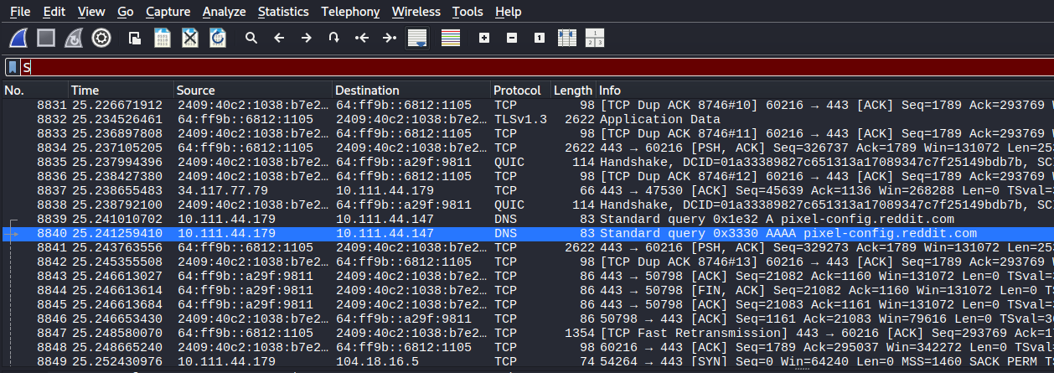

Key Findings
- DNS requests were observed when accessing websites
- HTTP traffic showed webpage requests
- TCP handled reliable communication
- Multiple IPs were involved (local + external servers)

Conclusion
This experiment demonstrated how Wireshark can be used to:
- Monitor real-time network activity
- Identify protocols
- Analyze communication between devices
It is a powerful tool for network troubleshooting and cybersecurity analysis.

